Jason- create some kind of query through mongoose by tomorrow

Sujay- presentation on free and open source editors

Protégé- enalbes editing of domain ontology

Class hierarchy

New update with plugin with semantic webrule language with math functions and temporal reasoning

Semantic web architecture with post and retrieve data from semantic web

Can take many formats for import and export

Axiom languages stored RDF triples in specific way (PAL)

Inference engines comes up with inferences or guesses on relationships which are not specifically stated

Can merge ontologies which are stored in files or database

One con in protégé: no easy visualization

Apollo- modelling application whichi standalone semantic architecture

Only encodes in Apollo meta language

Unrestricted axiom language

Can’t merge ontologies

Can’t collaborate and no visualization

Swoop-OWL validation, reasoning support, hyper linked capabilities (simple navigation for user interface)

IsaViz- visual environment for editing RDF, OWL; inference engine, cannot merge, visualization via plugins like Graph Viz

Owl Gred- combines UML + Manchester syntax, ontology authoring (can open and edit ontologies); can be exported to protégé, ontology visualization

Protégé+owlGred Visualization Combination

Protégé: Easy UI, quick format conversion

OwlGred: visualization, import from Protégé

Sujay -Live demonstration of OWL 2.0 editor where you actually see the editor and code environment and example file of OWL ontology

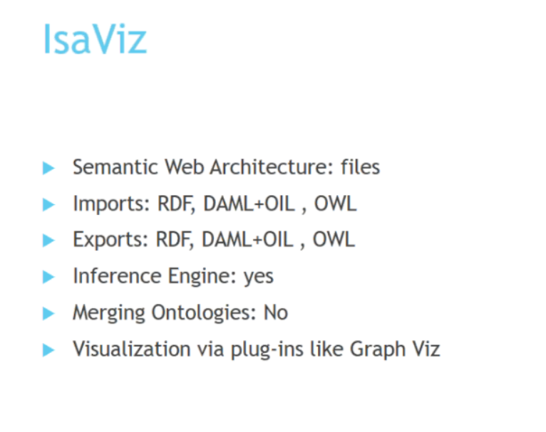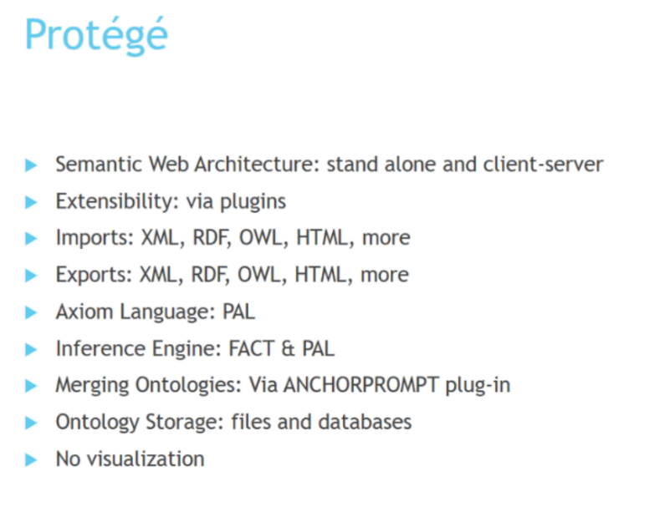

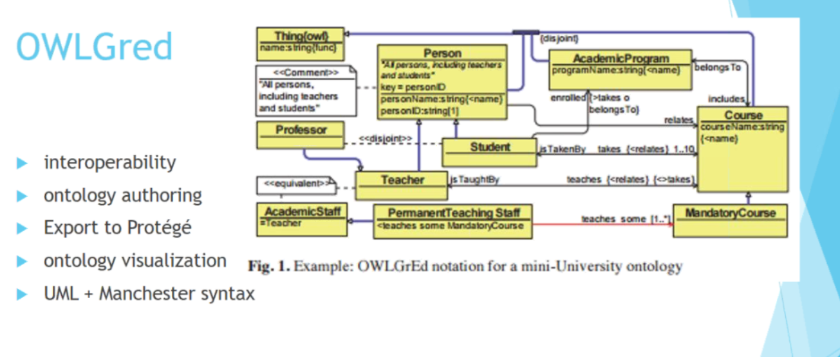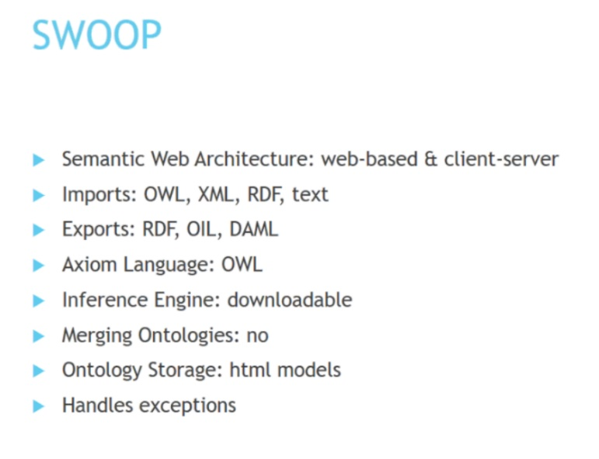

Ben- citation converter for PDS XML to bibtech format

Makes articles which he finds into a JSON object

Daniel-mini demo on angular.js or something to do with front end